

| Name of Student |  | ID | 1 |
| --- | --- | --- | --- |

**Assessment 1 – Case Study**



**Contents**

Instruction: 2

Duration: 2

Case Study: 2

Going Green application, Green IT Project Management 2

Project profile 2

Here is my software running on my phone! Or Access by: 4

Business situation 4

Your tasks: 5

Task 1: Identify Business Strategy and Gap 5

Analyse Strategy 5

Task 2: Recommend a feasible solution 6

Task 3: Produce a Project Charter 6

Task 4: Project Document 8

Task 5: Project Closure 9

Helpful web links to complete the assessment: 12

Search Index 13

## Instruction:

This task is to be completed individually. You need to analyse a case scenario and complete all the tasks mentioned after the scenario.

You need to demonstrate your IT project management ability to identify business strategy and gaps. You will also need to suggest a feasible solution to overcome identified gaps and produce a project charter along with a WBS to implement the proposed solution.

### Duration:

Trainer will set the duration of the assessment.

All my working could be checked at: <https://wellsjohn220.github.io/pm12345t32022>

## Case Study:

### Going Green application, Green IT Project Management

# Project profile

Going “Green” is a mission of many companies around the globe not just for reasons of environmental responsibility, but also for cutting costs in these extremely tight economic times. Green IT efforts represent a specific focus area within enterprises that hold attention to this trend. Green IT leverages information technology to streamline operations, cut costly waste, and reduce the impact on the environment. IT typically consumes only about 10% of an organization’s energy costs, but the net effect of a Green IT project is to go beyond just energy saving. To tackle the other 90%, a Green IT project extends into a variety of other departments, and to execute such an endeavour requires an effective project management function in order to identify and prioritize goals. A Green IT transformation can be a complex process.

Vital Statistics:

* Number of project tasks - 12
* Project duration - 16 months
* Project budget - $1,200,000
* Number of users - 50

I used google sheets to make a business project management gantt chart.

Link URL: [Cloud migration](https://docs.google.com/spreadsheets/d/1n6YafeOj4dLElY750qV6Ho2hkt5CyVPnfwWSQ6Z3M1E/edit?usp=sharing)

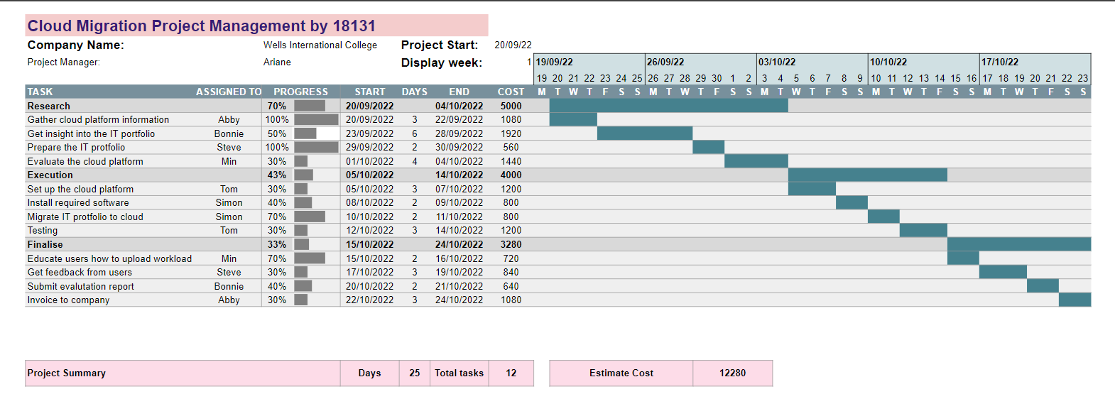

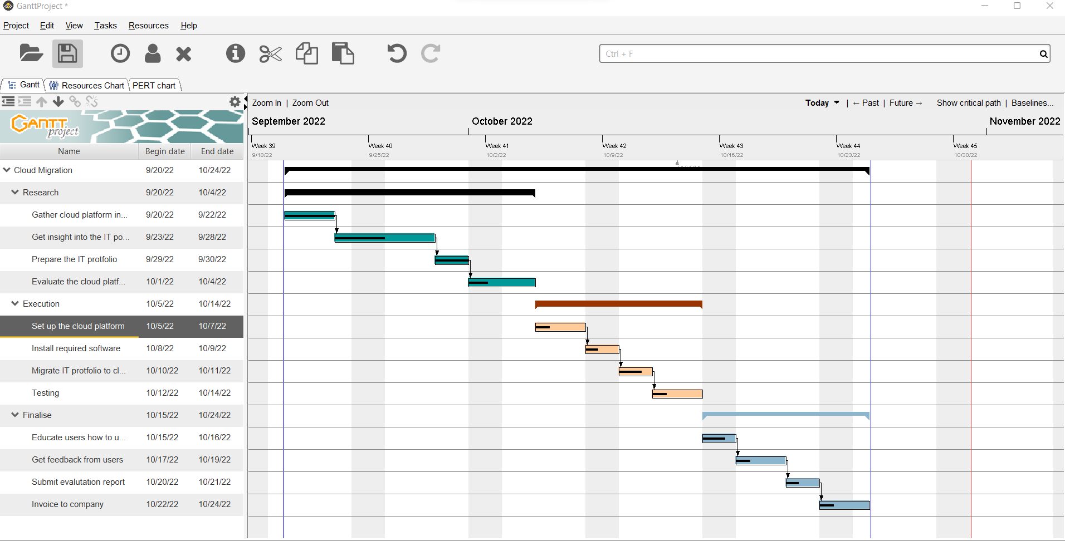

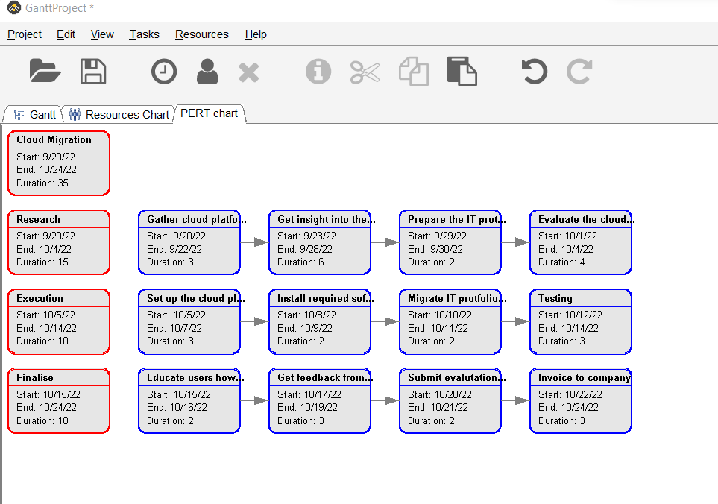

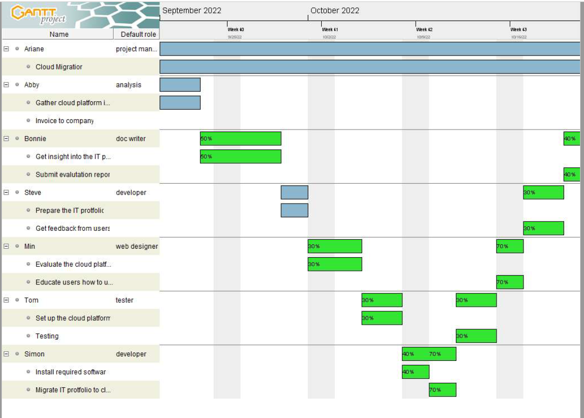

### Business situation

Sample Summary Report:

In order to reduce carbon dioxide emissions, we would like to do cloud migration. Our main goal is to cut down paper consumption 30% by the end of this year.

## Your tasks:

### Task 1: Identify Business Strategy and Gap

Document the business’s strategies of “Green IT” and also summarise the components required changes for the participating organisation to implement “Green IT Project”. (Min. 300 words)

Business strategy is a planning function of any organisation. Business strategy incorporates having a strategic plan.

First of all, I will define our business goals, and also need to define what my future state looks like. We are going to use goals, historical data, and past gap analyses to benchmark our current business performance, processes, or [workflows](https://asana.com/resources/workflow-examples), and set the standard for how we work.

At the same time, evaluate our current processes with a business process analysis (BPA).

Gap analysis is the difference between where our business currently stands and where we want our business to be. We will hypothesize different [strategies and tactics](https://asana.com/resources/strategy-vs-tactics) that our team will need to close that gap.

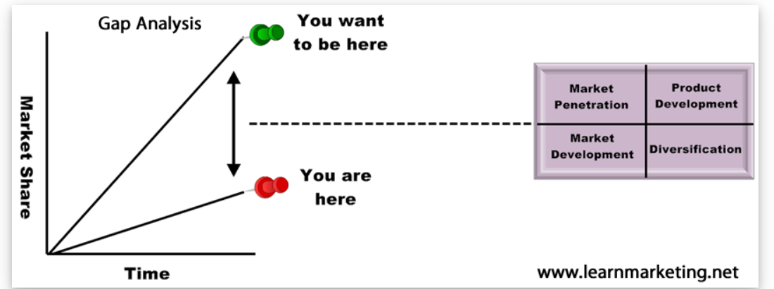

### Task 2: Recommend a feasible solution

Assume “Wells International College” is thinking of going “Green” and asked for your assistance in this project. Research different project management applications on the Internet to compare with the Green IT project management application and recommend a feasible solution with proper reasons for Windsor. (Min. 300 words)

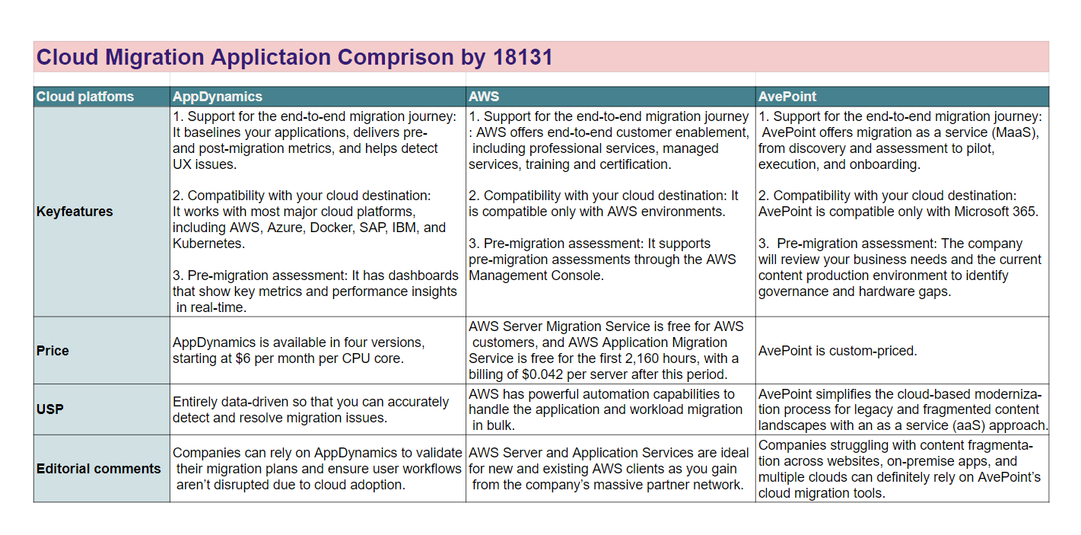

**Conclusion:**

We decided to choose AppDynamics as our Cloud Migration system. The reason we use it is because it is convenient, fast and secure. It has speed innovation and delivers flawless and secure experiences with AI-powered answers that help teams proactively predict and resolve problems. Moreover, in terms of total cost, it is also cheaper than other 2 applications.

### Task 3: Produce a Project Charter

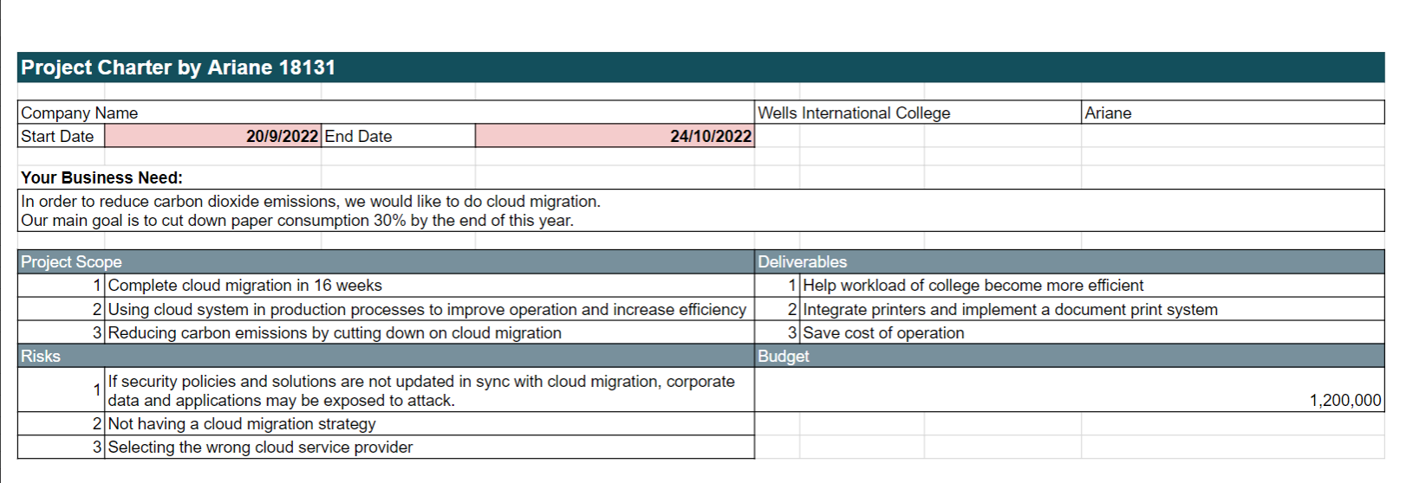

Develop a project charter for the Windsor project specifying project start date, finish date, approximate budget, project manager, project team with roles and responsibilities, project objective, project approach and stakeholders.

Name: Cloud Migration

Description: In order to reduce carbon dioxide emissions, we would like to do cloud migration.

Our main goal is to cut down paper consumption 30% by the end of this year.

Manager: Ariane

Date Approved: 16Sep 2022

...

### Task 4: Project Document

Please check my site: <https://arianesun.github.io/PM18131/>

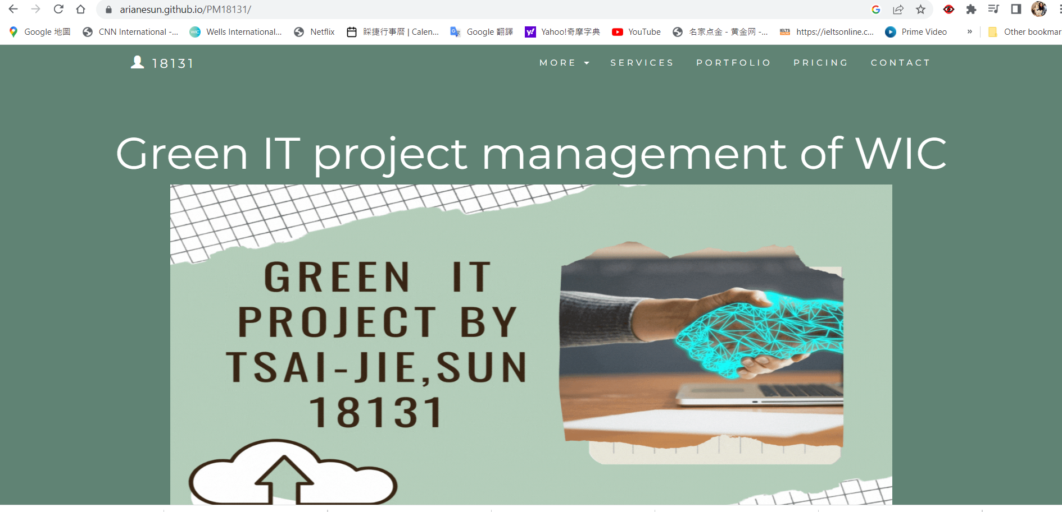

Please replace the images below:

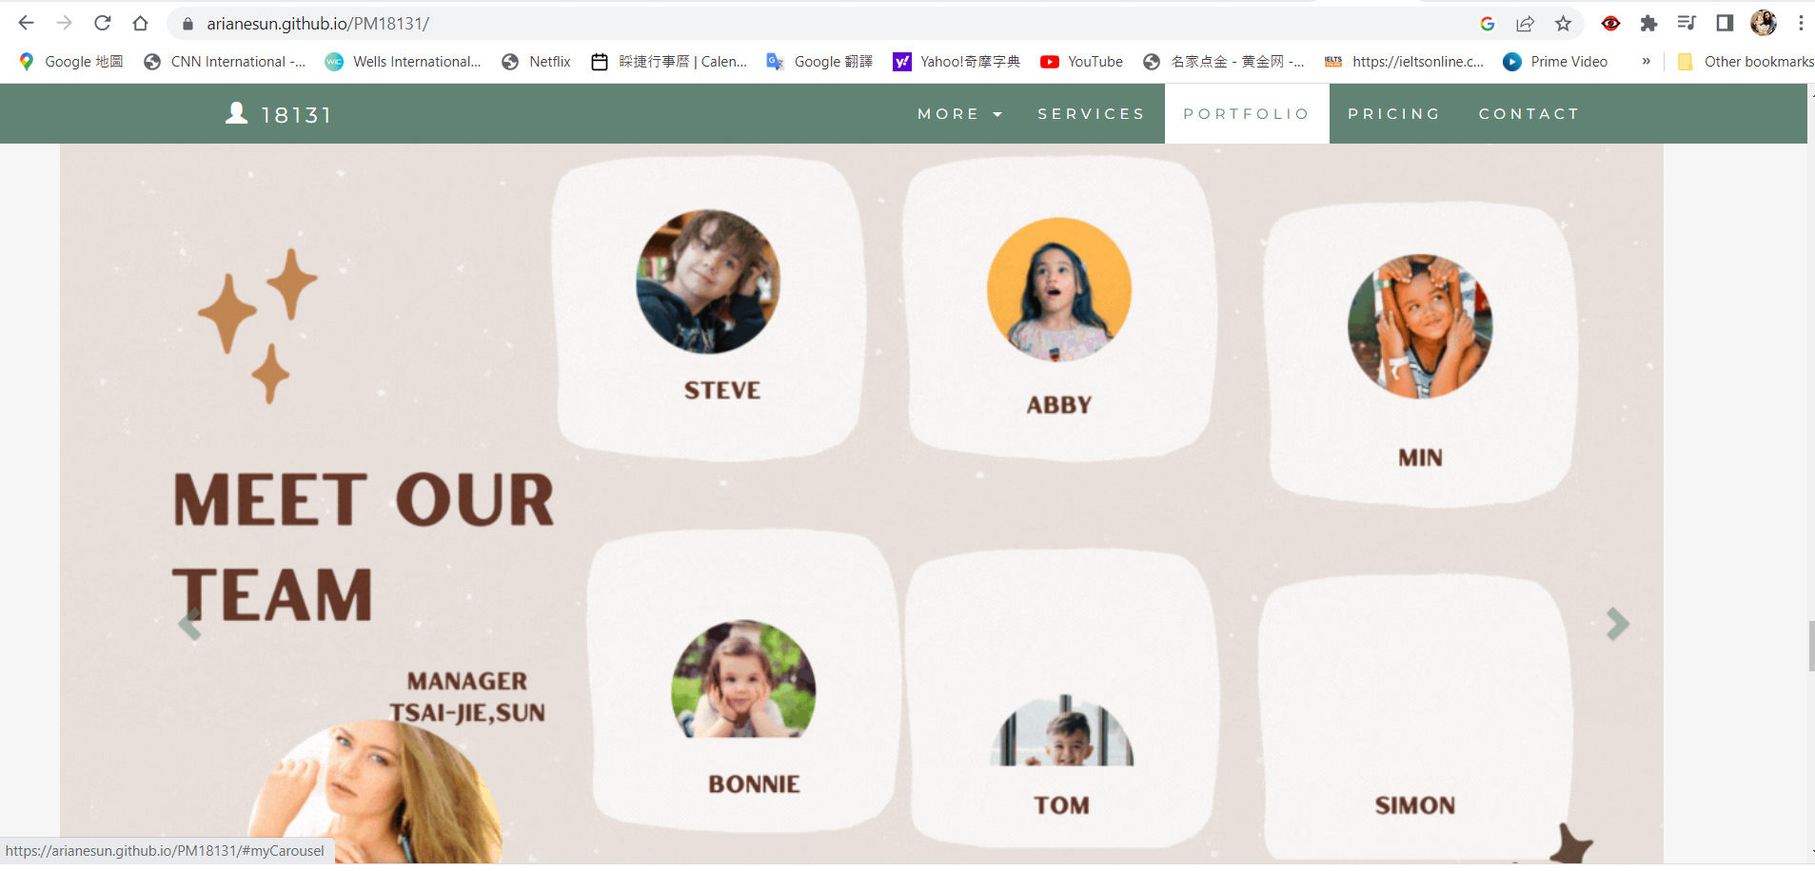

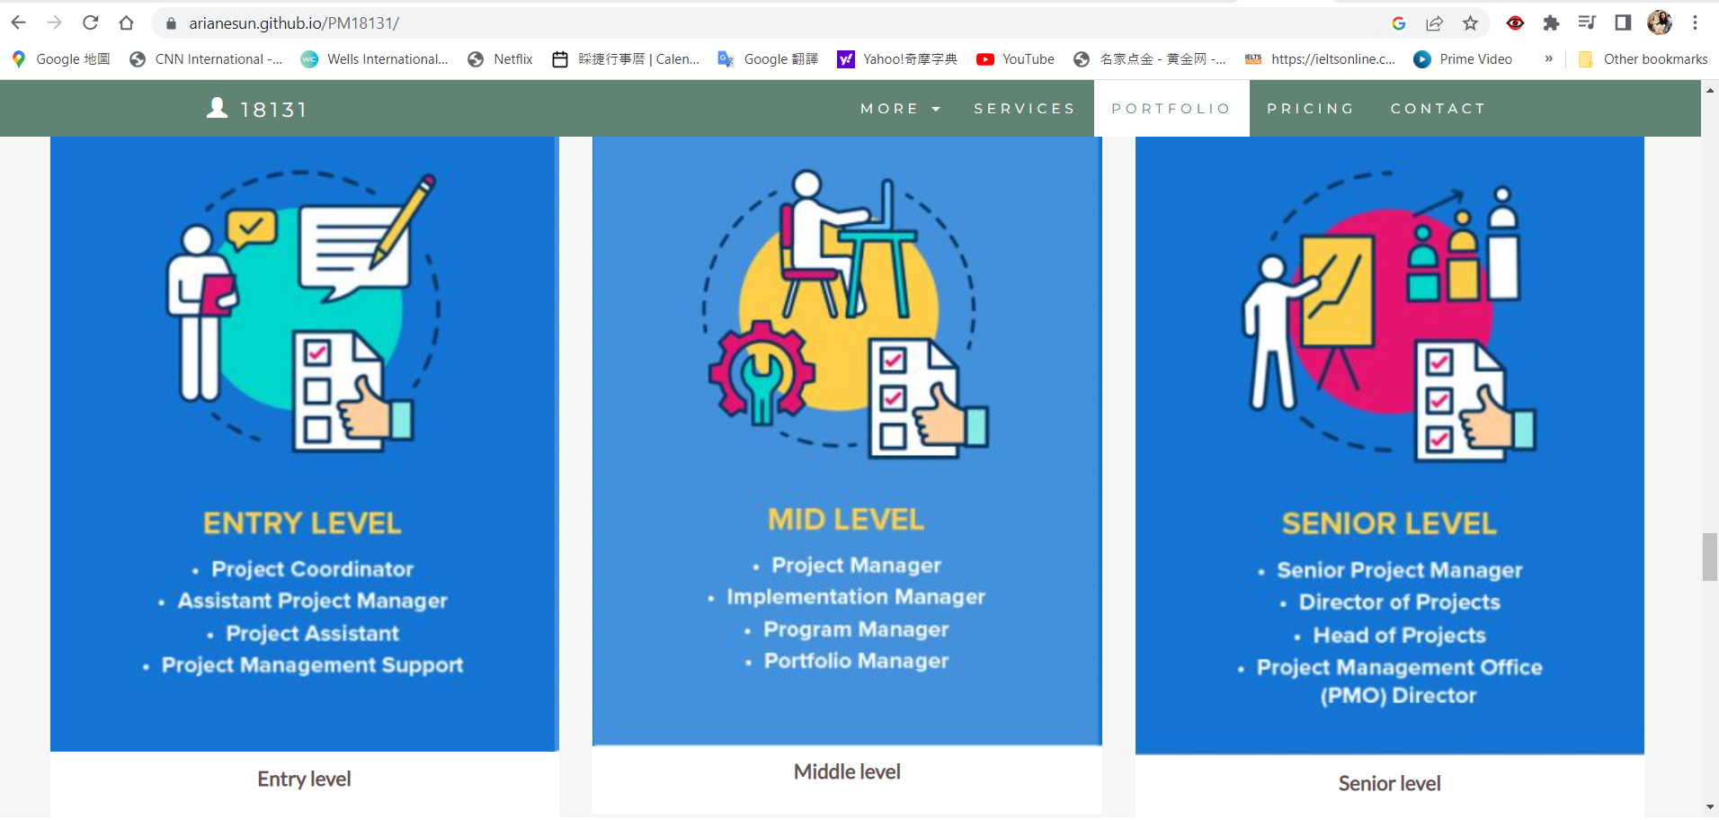

Refer to your current project, you have been asked to develop a project plan for WIC. Project plan outline as following:

In my Green project, I design following topics:

* Introduction (Select one recommendation from Task 2 for implement project plan)

Green IT (green information technology) is the practice of environmentally sustainable computing. Green IT aims to minimize the negative impact of IT operations on the environment by designing, manufacturing, operating and disposing of computers and computer-related products in an environmentally-friendly manner.

The motives behind green IT practices include reducing the use of hazardous materials, maximizing energy efficiency during the product's lifetime and promoting the biodegradability of unused and outdated products.

The concept of green IT emerged in 1992 when the U.S. Environmental Protection Agency launched Energy Star, a voluntary labeling program that helps organizations save money and reduce greenhouse gas emissions by identifying products that offer superior energy efficiency. Other components of green IT include the redesign of data centers and the growing popularity of virtualization, green networking and cloud computing.

* Project background

We aim to reduce paper consumption 30% by the end of this year 2022, and put effort into providing a paperless working environment to help carbon dioxide emissions.

* Related factor to organization

Strategy

People

Technology

Environment

* Scope and objective of the project

Complete cloud migration in 16 weeks

Using cloud system in production processes to improve operation and increase efficiency

Reducing carbon emissions by cutting down on cloud migration

* Information gathering plan and approach

Identify the priorities in the needs of the green IT project.

Ensure that our organization's goals match with the expectations of the project. Create a database of information that can help make systematic and effective interventions within this project.

Use the findings to develop a strategic plan and action plans that meet the real expectations of the requirements in the project.

* Gathering method, can be one of the following
* Interview

We will get feedback from users.

* Questionnaire

We will create a survey to ask about the satisfaction of the cloud platform, and also find out how we can improve in the future.

* Observation

Observations are one of the [tools](http://project-management-knowledge.com/definitions/t/tool/) and requirements under collect requirements. Together with questionnaires and surveys, focus groups, facilitated the workshop, [prototypes](https://project-management-knowledge.com/definitions/p/8-prototypes/), [document analysis](https://project-management-knowledge.com/definitions/d/document-analysis/), [context diagram](https://project-management-knowledge.com/definitions/c/context-diagrams/) and benchmarking, observations are used to create the project documentation and the [requirement traceability matrix](https://project-management-knowledge.com/definitions/r/requirements-traceability-matrix/). All of these will eventually be used to define the scope of the project.

* Detail of information repositories

We will name every file and write down description when we upload, and create SOP for sorting our different types of documents.

* Feasibility studies

We will confirm market opportunities before committing to a project

Narrow our business alternatives

Create documentation about the benefits and detriments of our proposed initiative

Provide more information before making a go/no go decision

* Technical

We will have to pay for cloud service to get our project done.

* Operational

Setting project management guidelines.

Structuring data networks for consistent access.

Managing inventory and workforce levels.

Implementing quality control measures.

* Economical

Make sure we run this project under the budget.

Ensure that scarce resources are allocated efficiently, and investment brings benefits to this budget.

* Social

We will analyze the different stakeholder perspectives and priorities.

* Project plan and schedule

Please see my gantt chart

* Work breakdown structure

We will break phrases of the project down into smaller chunks.

WBS meaning work can be done simultaneously by different team members, leading to better team productivity and easier project management.

* Gantt Chart



* Milestone

We achieve milestones after we finish every task of different phrases of the project.

* Project Deliverable

Help workload of college become more efficient

Integrate printers and implement a document print system

Save cost of operation

* Communication plan

It will help our team understand who should be getting which notifications and when to loop in project stakeholders. As part of our communication plan, we’ll clarify which channel stakeholders should use and when, how frequently different details should be communicated, and who is responsible for each of the different channels.

* Deployment Plan (If needs)

We don’t need this plan in our project.

* Training Plan (If needs)

We will set up guidelines for users to read.

We also offer 3 days of online courses for staff to learn how to use new cloud applications.

Educators from the cloud application side will come to WIC to demonstrate the process of cloud migration.

* Recourse and budget, (budget has been limited by WIC Capital Expenditure of current fiscal year for Hardware $80,000, Software $10,000, and Outsourcing man-hours $100,000)

Please see google sheets of cloud migration

* Risk Management

keeping in view the fundamental goal of protecting the organisation's information assets against emerging threats.

Many systems were not built with modern business continuity and disaster recovery plans in mind.

* Risk identified

If security policies and solutions are not updated in sync with cloud migration, corporate data and applications may be exposed to attack.

Not having a cloud migration strategy

Selecting the wrong cloud service provider

* Contingency plan

Consider user experience issues.

Get control over the cloud traffic

Include an updated list of data access permissions, dependencies, and data controls.

* Change management

Changes can impact processes, systems, tools, organization structures or job roles.

Customize and scale your approach.

Dedicate a resource.

Work in collaboration with the project team.

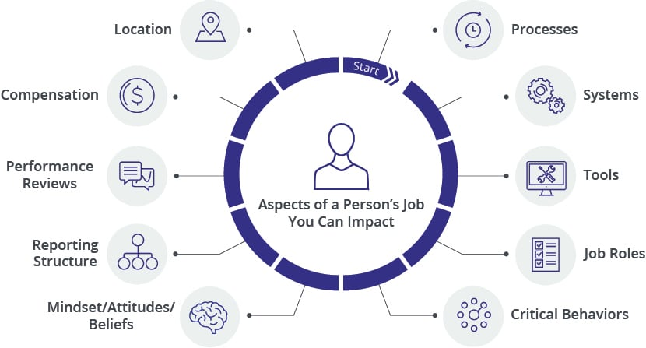

* Change control

Identify change proposal

Find out how that change will impact this project.

Make a decision to change or not change.

* Conflict management

Prepared for the consequences of partaking in the conflict.

Find a middle ground between all the needs, which would typically leave people unsatisfied or only satisfied to a certain extent.

### Task 5: Project Closure

Prepare project closure document template as following:

* Project Sign-off document

We will have Project Sign-off document after we finish the project, it should include:

* Project start date
* Project manager
* Project finish date
* If something is going wrong
* The project’s intended goals and whether they were met or not
* The project’s key deliverables and whether they were actually delivered
* Comments and observations, if any
* The project start and end dates

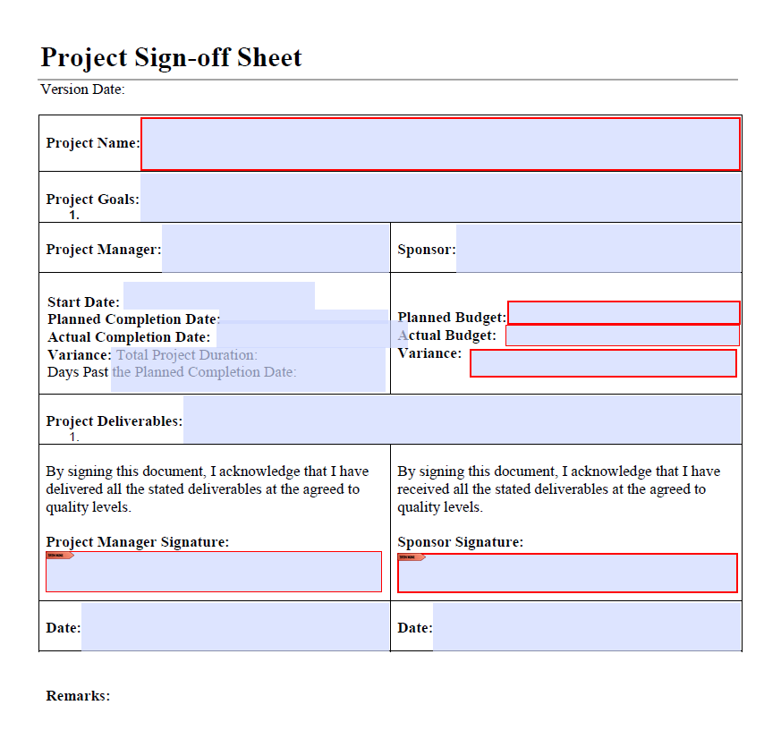

* Project evaluation document

Project evaluation is done on an ongoing or a concluded project and the project evaluation sheet records the findings. It aims to analyse to what extent the project has been able to achieve its goals. It also focuses on the other aspects such as the effectiveness, efficiency and sustainability of the project. A project evaluation template is used to get the basic format of the document or the sheet on which the results could be recorded.

* Challenges
* Our improvements
* Budget evaluation
* Quality evaluation

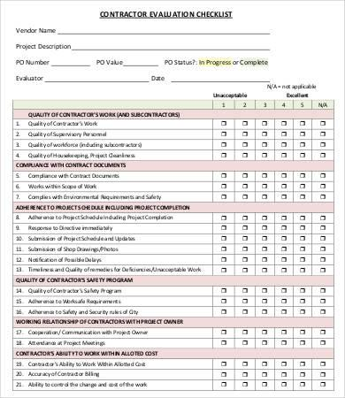

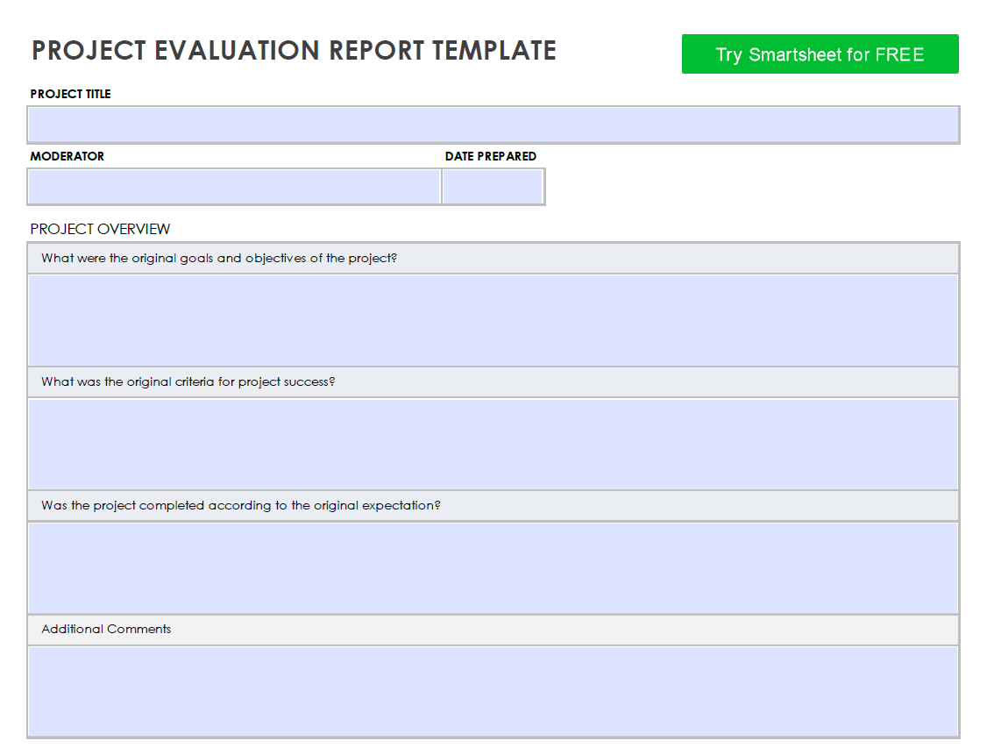

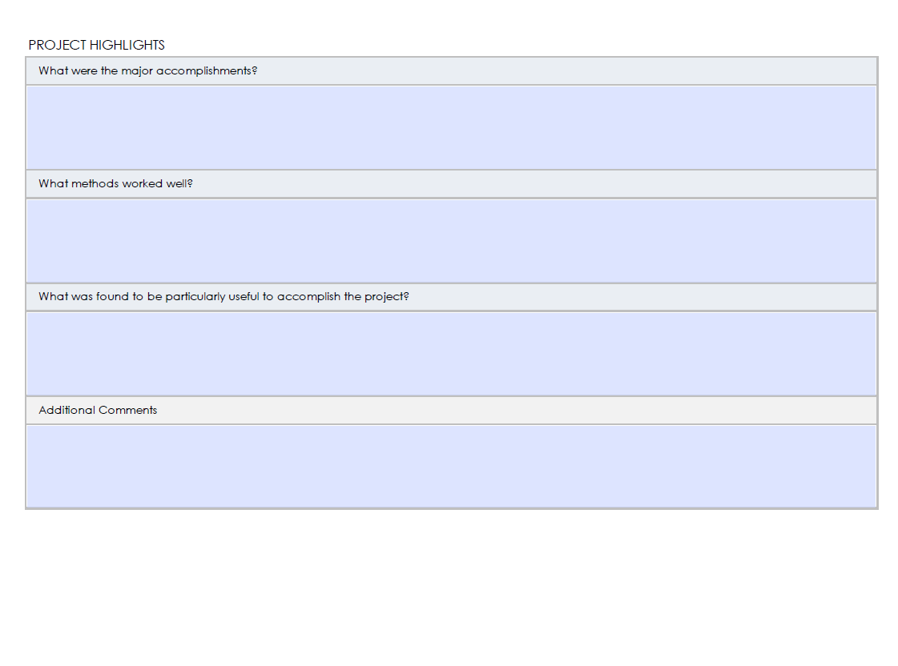

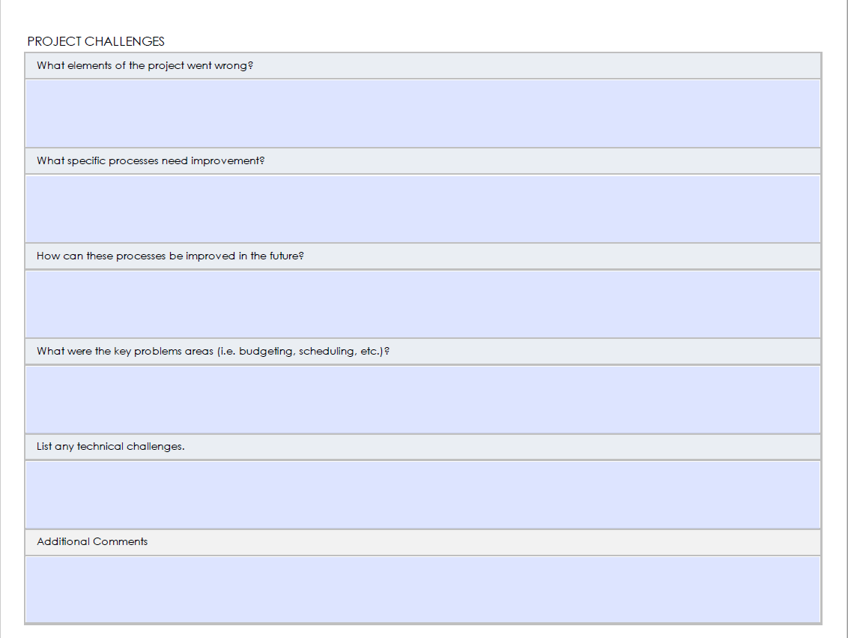

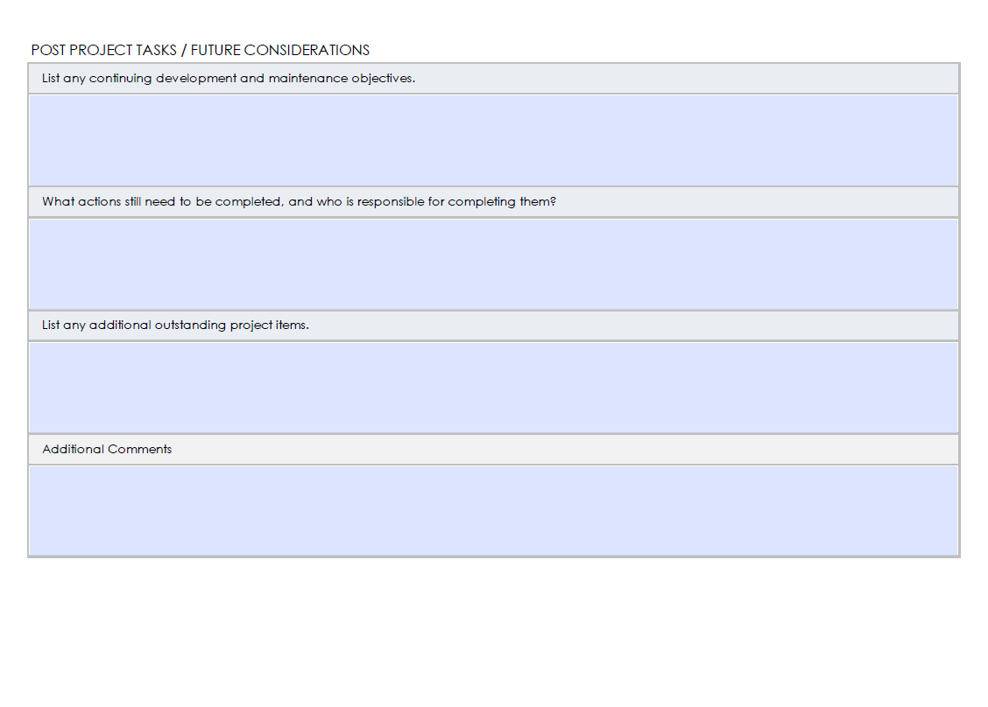

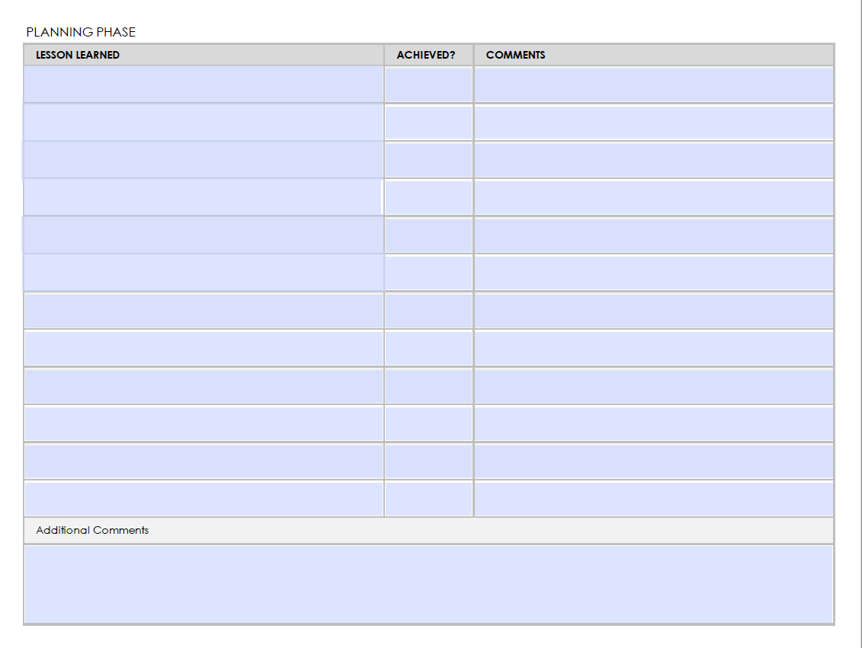

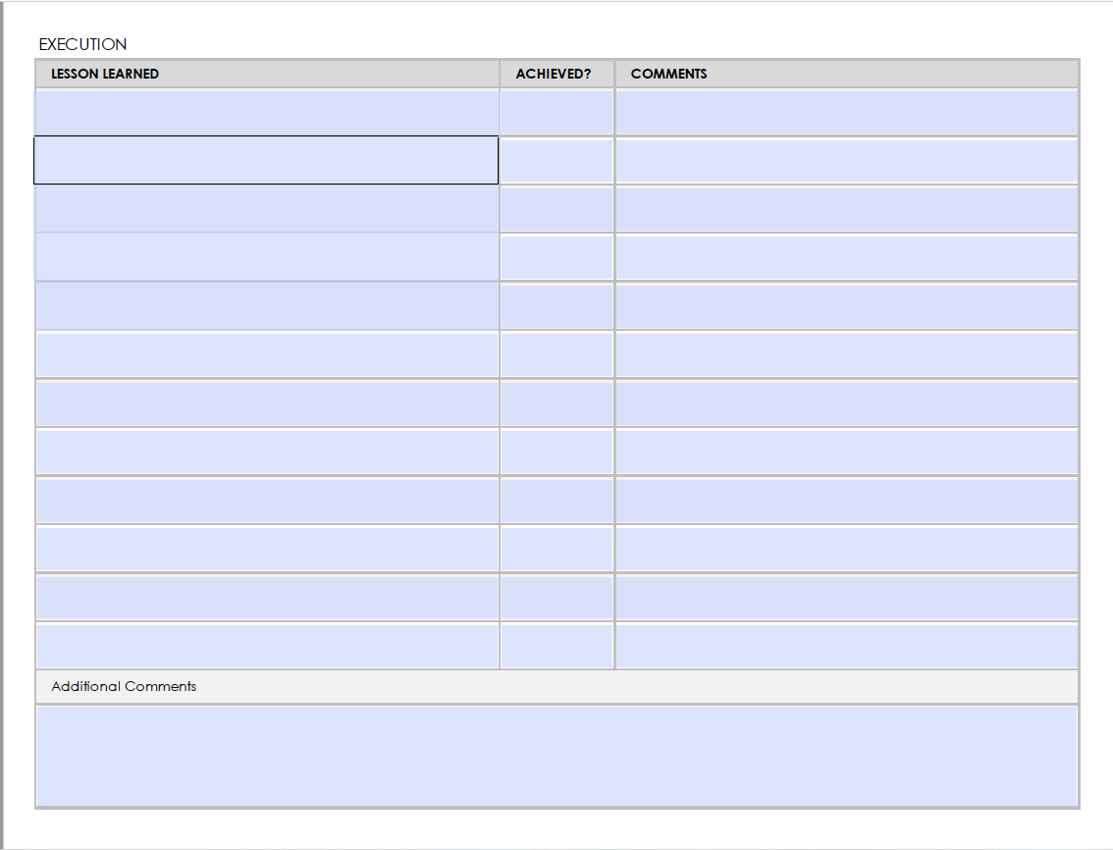

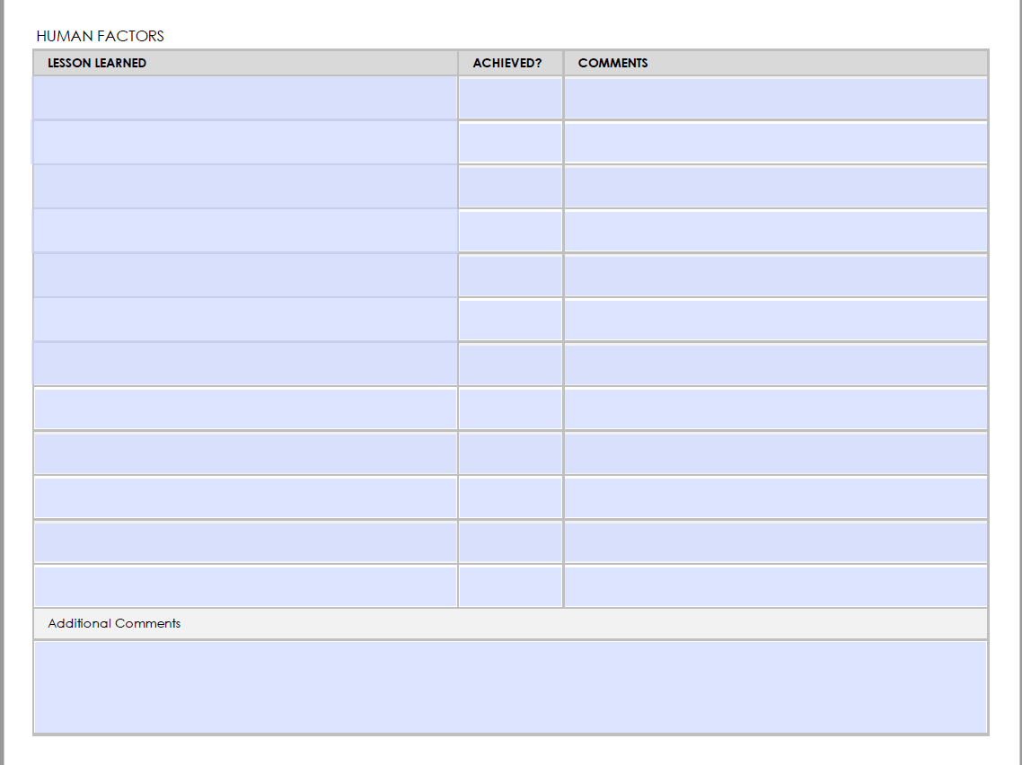

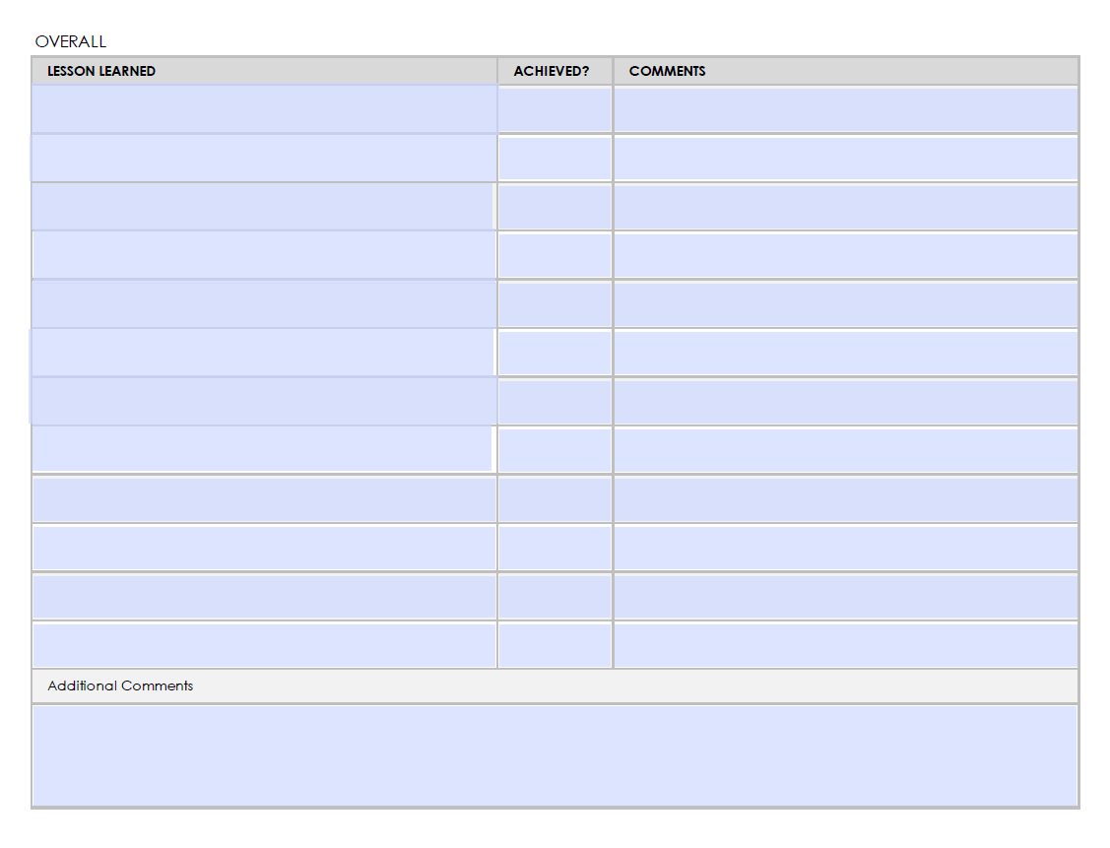

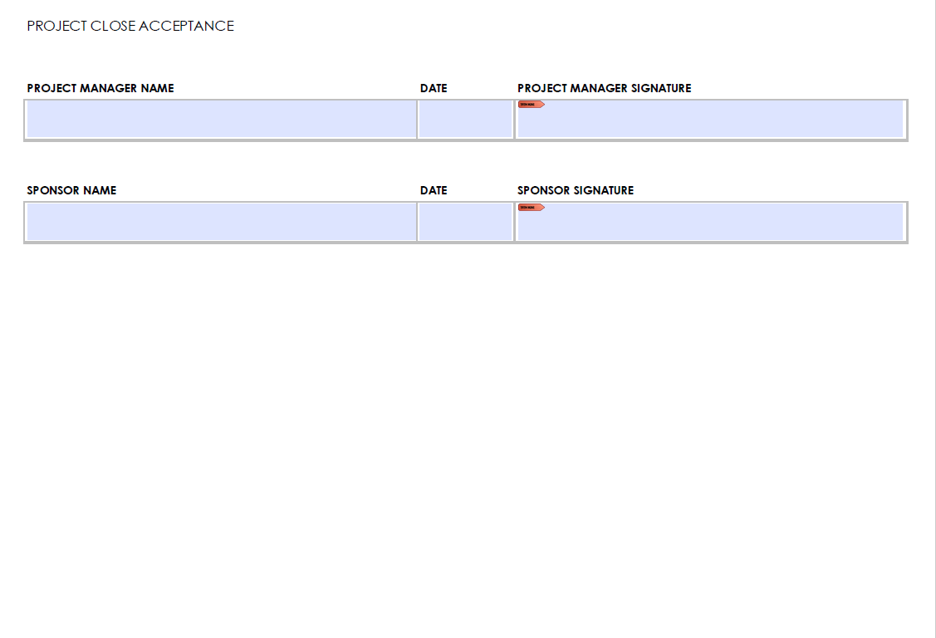

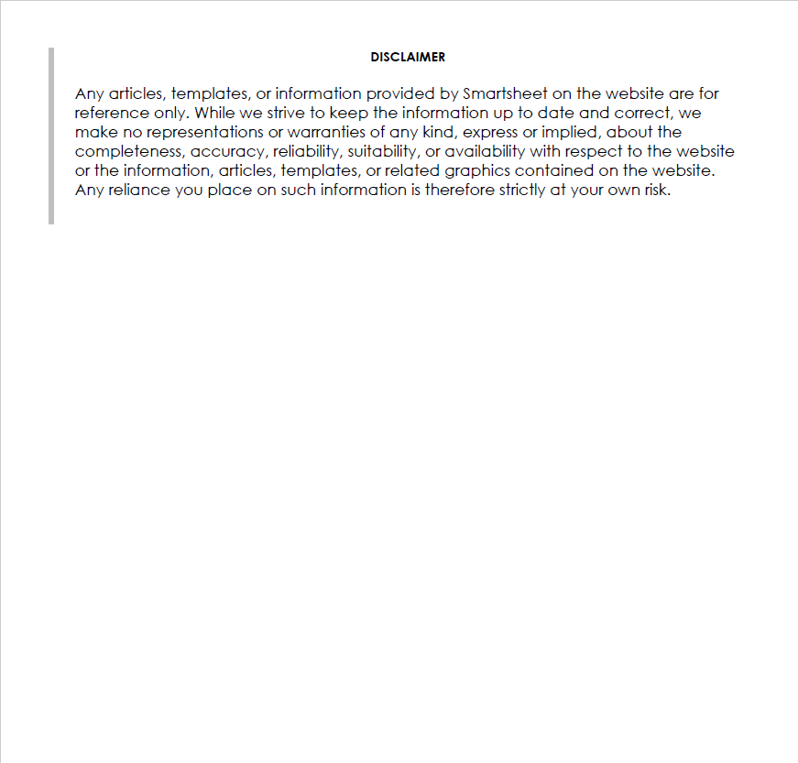

* Lesson learned template

What makes us to sucess this project?

What can we do better next time?

What methods worked well?

What have we learned from this project?

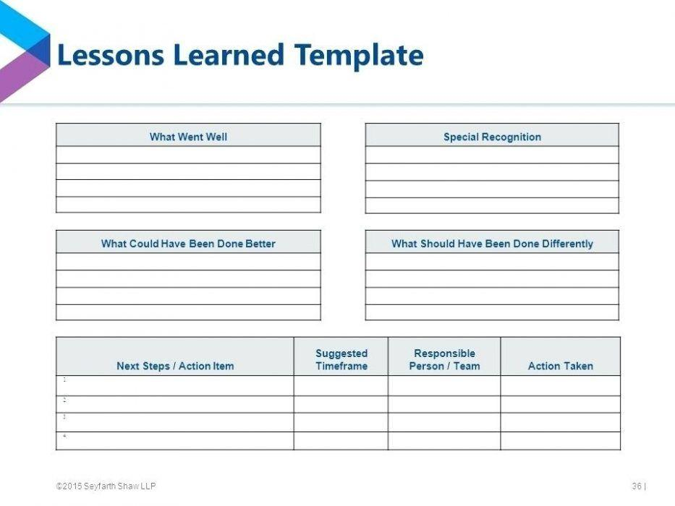

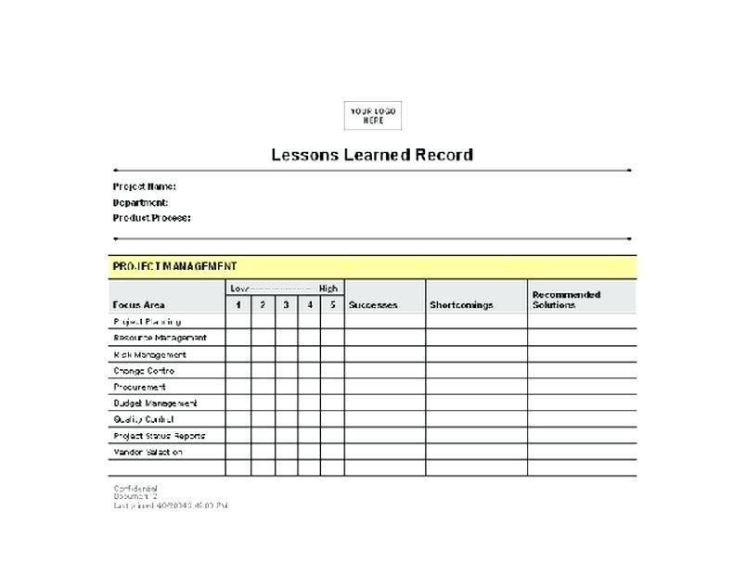

## Helpful web links to complete the assessment:

## Search Index

**B**

Benefit evaluation 10

Budget evaluation 10

**F**

feasible solution 1, 4

**P**

project sign off 9

**Q**

Quality evaluation 10

**S**

same mistake 10

scenario 1

specific focus 2